| PROJECT INFORMATION | | | |
| --- | --- | --- | --- |
| **Report Description:** | Feature Extraction | | |
| **Professor:** | Prof. [Gady Agam](mailto:agam@iit.edu) | **Tools used/work done:** | 1. Labeling 2. Initial Feature Extraction and training |
| **Report prepared by:** | [Noviya Balasubramanian](mailto:nbalasubramanian@hawk.iit.edu) |
| **HAWK ID:** | A20541236 |
| **Report no:** | 9 | **Report Date:** | 10/18/2024 |

**Timeline:**

1. **First 6 Weeks: Literature Review, Data Access, Preprocessing, Problem Statement Definition**
2. **Week 7 (Oct 4): Data Preprocessing Completion, MARA Exploration in MATLAB - Completed for 33 subjects**
3. **Week 8 (Oct 11): Labeling, Feature Extraction and Classification - Initial Training**
4. **Week 9 (Oct 18): Classifier Selection and Initial Training - Feature extraction**
5. Week 10 (Oct 25): Classifier Optimization and Validation
6. Week 11 (Nov 1): Multimodal Analysis
7. Week 12 (Nov 8): Fusion or Comparison Analysis Scope
8. Week 13 (Nov 15): Final Testing
9. Week 14 (Nov 22): Model Evaluation
10. Week 15 (Nov 29): Report Preparation (Buffer)
11. Week 16 (Dec 6): Report Submission

**Topic: Classification of Cognitive States Using EEG and Physiological Signals: Impasse, Aha!, Uncertainty**

- **Total Labels Loaded**: 853

**Feature Extraction**

[1] H. Chao and L. Dong, "Emotion Recognition Using Three-Dimensional Feature and Convolutional Neural Network from Multichannel EEG Signals," in *IEEE Sensors Journal*, vol. 21, no. 2, pp. 2024-2034, 15 Jan.15, 2021, doi: 10.1109/JSEN.2020.3020828.

Several time-domain features were computed from the EEG segments to facilitate analysis. The following features were extracted for each segment:

1.**Mean Features**:

- The mean of each channel across the time frames was calculated to provide an overall average signal level for each channel.

- Shape of mean features: (853, 16)

2.**Variance Features**:

- The variance of each channel was computed to assess the variability of the signal.

- Shape of variance features: (853, 16)

3.**Mean of Absolute First Difference**:

- This value indicates the average rate of change in the signal. A higher value suggests that the signal is fluctuating more significantly from one time point to another, which could indicate higher levels of activity or changes in cognitive states.

- Shape of first difference features: (853, 16)

4.**Mean of Absolute Second Difference**:

- This value indicates the average acceleration of changes in the signal. A higher mean suggests that not only is the signal changing, but it is also changing at an increasing rate. This can be critical in identifying sudden shifts in cognitive states or responses.

- Shape of second difference features: (853, 16)

**Combined Time Features**

The features were concatenated to create a comprehensive feature set, resulting in a combined feature set of:

- **Shape of Combined Features**: (853, 64)

- **Description**: The combined feature set includes the following components:

- Mean features (16)

- Variance features (16)

- Mean of absolute first differences (16)

- Mean of absolute second differences (16)

Accuracy: 0.26

Confusion Matrix:

[[28 11 0 0 8]

[37 8 2 0 10]

[ 4 0 0 0 0]

[ 3 1 0 0 0]

[35 16 0 0 8]]

Classification Report:

precision recall f1-score support

Aha 0.26 0.60 0.36 47

Doing Other Task 0.22 0.14 0.17 57

Impasse 0.00 0.00 0.00 4

Re-evaluation 0.00 0.00 0.00 4

Walking 0.31 0.14 0.19 59

accuracy 0.26 171

macro avg 0.16 0.17 0.14 171

weighted avg 0.25 0.26 0.22 171

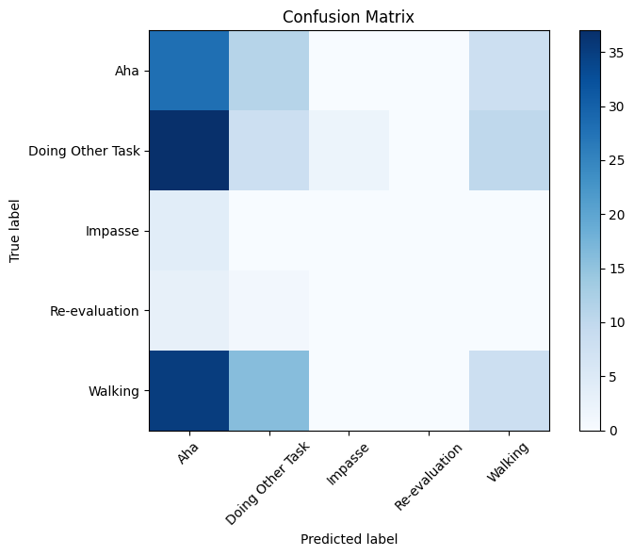

**Frequency Feature Extraction**

The following frequency-domain features were extracted using the spectrogram method from the EEG segments:

1.**Spectrogram Calculation**:

- For each segment, the spectrogram was computed to analyze the frequency content of the signals over time.

- This involved converting the time-domain signals into the frequency domain, finding how the power of the signal is distributed across various frequencies.

2.**Feature Vector Construction**:

- For each segment, a feature vector was constructed to represent the frequency characteristics.

- The resulting feature vectors encapsulate the frequency information across all channels.

3.**Shape of Frequency Features**:

- The final shape of the extracted frequency features is (853, 48), indicating that each segment is represented by a feature vector with 48 frequency-related features.

freqs, times, Sxx = spectrogram(channel_data, fs=125, nperseg=16)

Sxx_magnitude = np.abs(Sxx)

mean_power = np.mean(Sxx_magnitude)

std_power = np.std(Sxx_magnitude)

peak_freq = freqs[np.argmax(np.mean(Sxx_magnitude, axis=1))]

**Mean Power** provides a measure of the overall strength of brain activity.

**Standard Deviation of Power** indicates how consistent or variable that activity is across the frequency spectrum.

**Peak Frequency** highlights the frequency of maximal activity, which can be particularly relevant for understanding cognitive processes or states.

(853, 112)

[[16 20 0 0 11]

[22 15 0 0 20]

[ 1 3 0 0 0]

[ 1 0 0 0 3]

[27 22 0 0 10]]

precision recall f1-score support

Aha 0.24 0.34 0.28 47

Doing Other Task 0.25 0.26 0.26 57

Impasse 0.00 0.00 0.00 4

Re-evaluation 0.00 0.00 0.00 4

Walking 0.23 0.17 0.19 59

accuracy 0.24 171

macro avg 0.14 0.15 0.15 171

weighted avg 0.23 0.24 0.23 171

Accuracy: 0.24

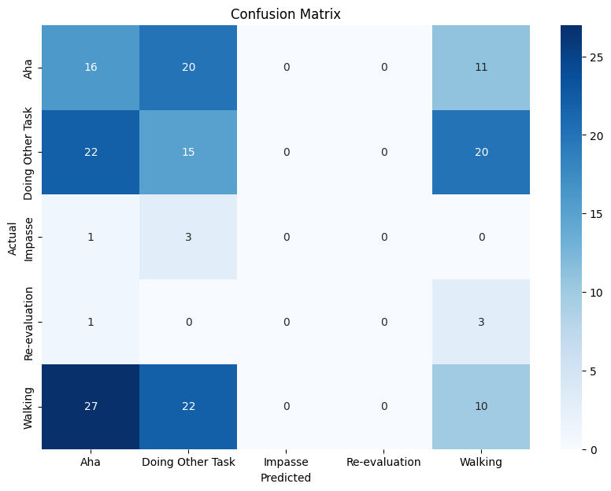

**The combined features consist of both time-domain and frequency-domain characteristics extracted from EEG segments.**

**CNN Model Architecture**

The CNN was defined as follows:

- **Input Layer**: Shape (112, 1, 1)

- **Convolutional Layers**:

- First Conv Layer: 32 filters, kernel size (3, 1), ReLU activation

- MaxPooling Layer: Pool size (2, 1)

- Second Conv Layer: 64 filters, kernel size (3, 1), ReLU activation

- MaxPooling Layer: Pool size (2, 1)

- **Flatten Layer**: To convert the 2D matrix into a 1D vector

- **Dense Layers**:

- First Dense Layer: 128 neurons, ReLU activation

- Output Layer: Softmax activation for multi-class classification

final Dense layer uses the softmax activation function, which is designed for multi-class classification tasks. This layer will output a probability distribution across the classes.

(Time + CNN) + (Spect +CNN); Both - Summary + CNN features

1s, 5s

[[10 8 0 0 29]

[10 11 0 0 36]

[ 2 0 0 0 2]

[ 0 1 0 0 3]

[10 11 0 1 37]]

precision recall f1-score support

Aha 0.31 0.21 0.25 47

Doing Other Task 0.35 0.19 0.25 57

Impasse 0.00 0.00 0.00 4

Re-evaluation 0.00 0.00 0.00 4

Walking 0.35 0.63 0.45 59

accuracy 0.34 171

macro avg 0.20 0.21 0.19 171

weighted avg 0.32 0.34 0.31 171

Accuracy: 0.34

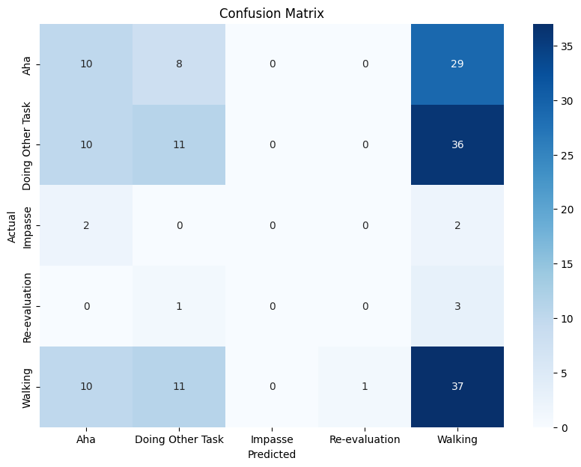

Todo:  
1. **Feature Engineering**

**2. Improvise the labeling**

**3.**